Students of the Month for November 2016

7th | Marissa Byrd
 | 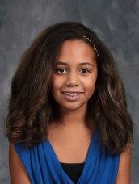
8th | Brandon Palmer
 | 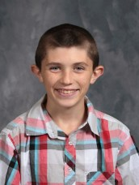
9th | Dwyitte Manche
 | 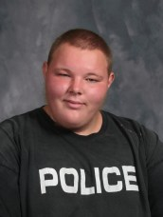
10th | Christine Secoy
11th | Zac Liley
 | 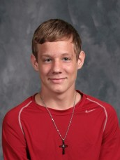
12th | Brittney Marshall  